**Lab Assignment 4.3**

**Task Description#1**

Zero-shot: Prompt AI to write a function that checks whether a given year is a leap year.

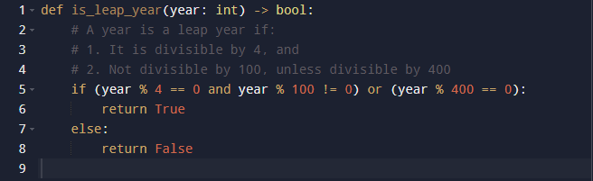

**Observation:**  
Zero-shot prompting works fine since the leap year rule is straightforward. The model generates a correct function without needing examples.

**Task Description#2**

* One-shot: Give one input-output example to guide AI in writing a function that converts centimeters to inches.

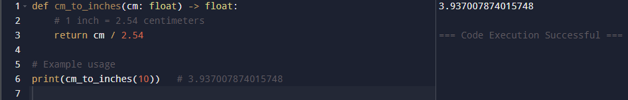

**Observation:**  
One-shot prompt with a single example ensures the model applies the conversion correctly. It also improves accuracy by reinforcing the unit relationship.

**Task Description#3**

* Few-shot: Provide 2–3 examples to generate a function that formats full names as “Last, First”.

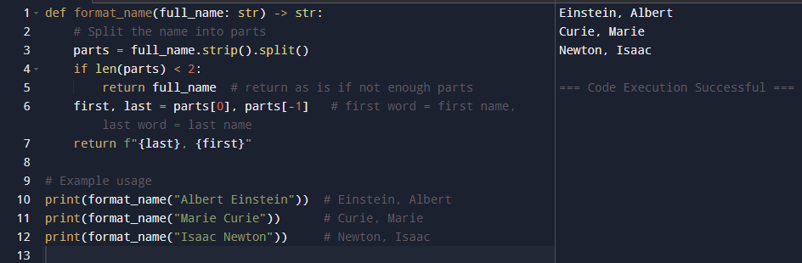

**Observation:**  
Few-shot examples guide the model to consistently format names. Multiple examples help it generalize better, even for different input cases.

**Task Description#4**

* Compare zero-shot and few-shot prompts for writing a function that counts the number of vowels in a string.

Zero-shot Prompt:

Write a function that counts the number of vowels in a string.

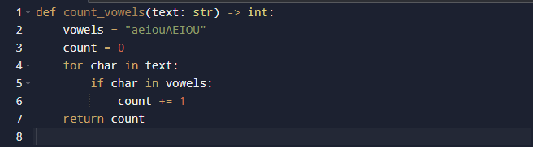

Few-shot Prompt:

Now write a Python function count_vowels that behaves the same way.

Input: "hello" → Output: 2

Input: "Python" → Output: 1

Input: "AEIOU" → Output: 5

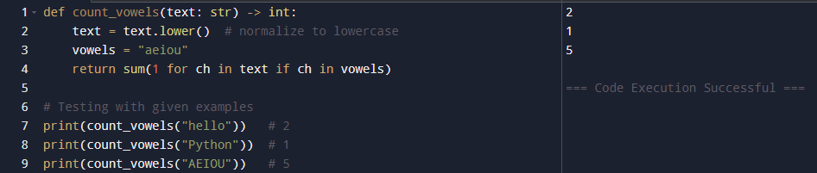

**Observation:**  
Zero-shot produces a basic correct function but may miss case handling. Few-shot creates a cleaner, optimized, and case-insensitive solution.

**Task Description#5**

* Use few-shot prompting to generate a function that reads a .txt file and returns the number of lines.

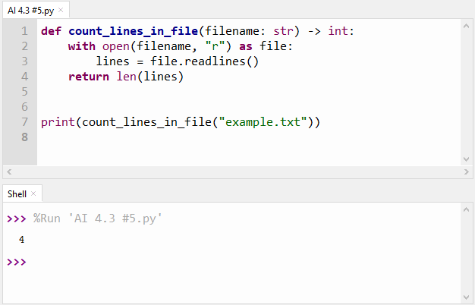

**Observation:**  
Few-shot examples clarify that the task is counting lines, not words. The generated function is simple, accurate, and directly uses file operations.